LAB – 2

Part: A 1. Perform the following Unix Commands: who, whoami, uname, passwd, mkdir, rmdir, cp, mv, rm, cut, paste, more

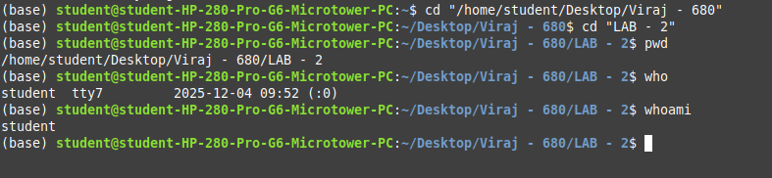
next :
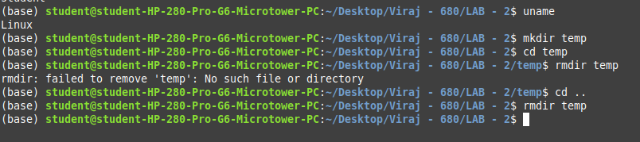
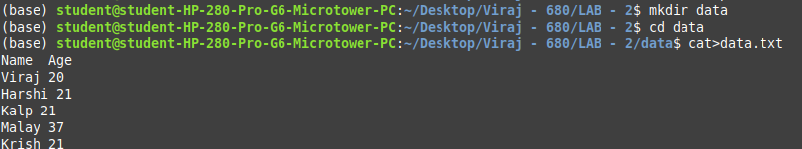

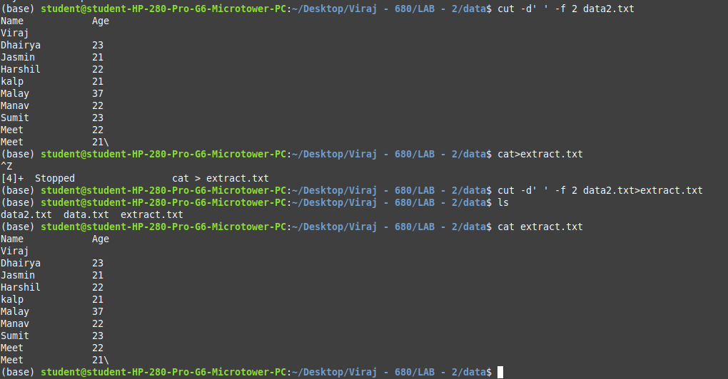

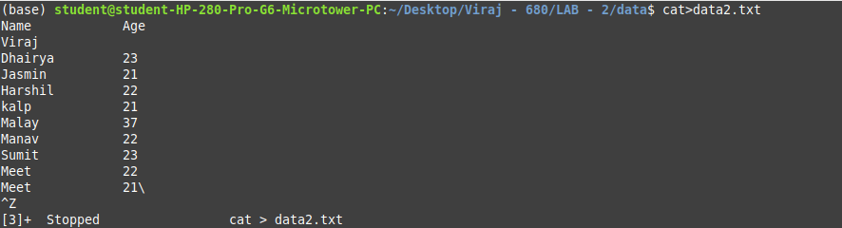
next :

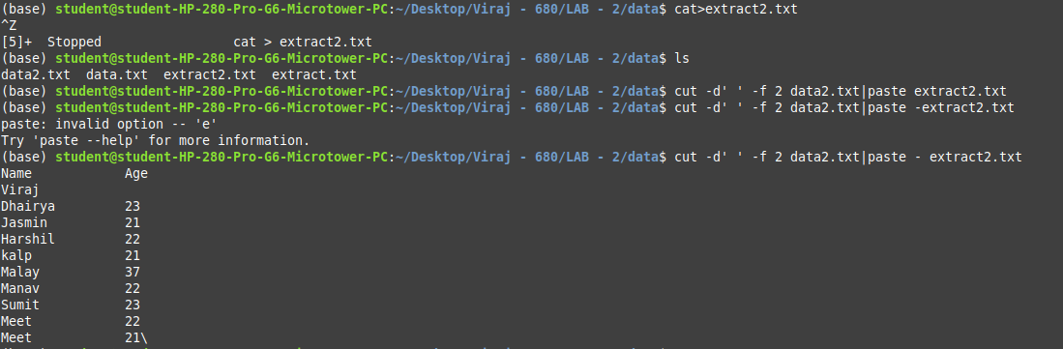

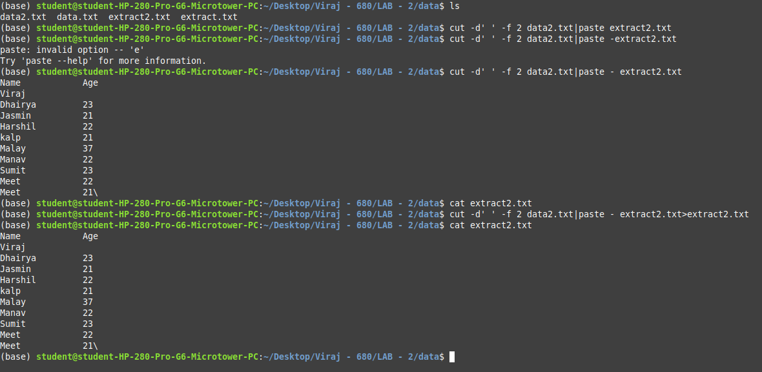

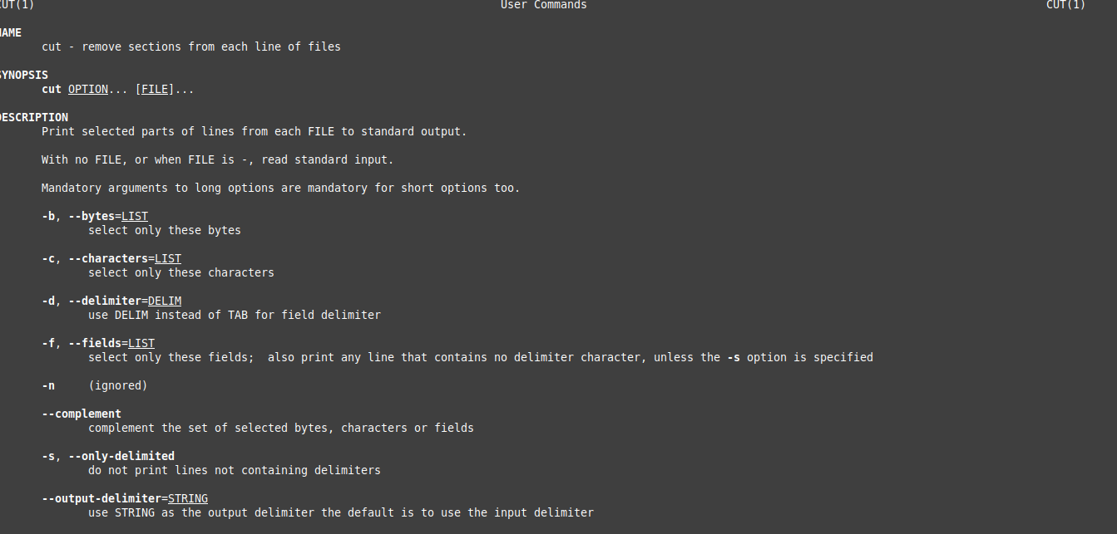

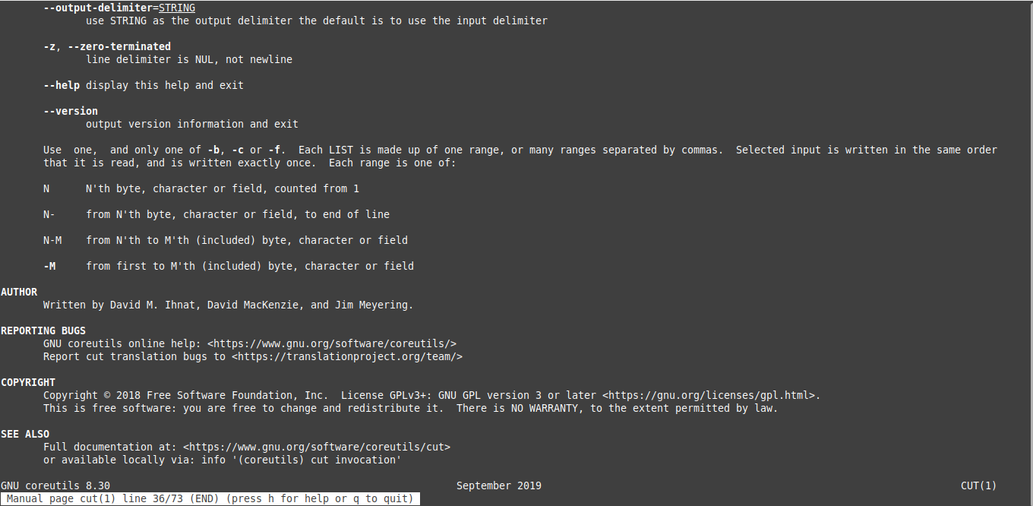

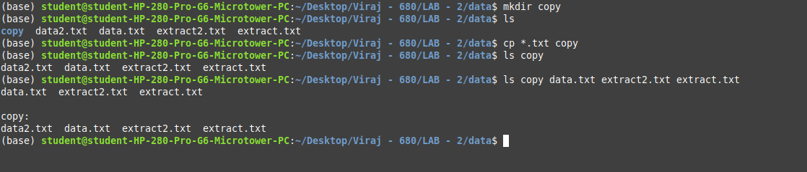
-

Command | Description | Example
who | Shows who is currently logged in | who
whoami | Shows your own username | whoami
uname | Displays system information (kernel, OS) | uname -a
passwd | Changes your password | passwd
mkdir | Creates a directory | mkdir myfolder
rmdir | Removes an empty directory | rmdir myfolder
cp | Copies files | cp file1.txt file2.txt
mv | Moves or renames files | mv old.txt new.txt
rm | Removes files or folders | rm file.txt
cut | Extracts fields/columns from a file | cut -d"," -f1,2 data.txt
paste | Merges files column-wise | paste file1 file2
more | Displays content page by page | more file.txt

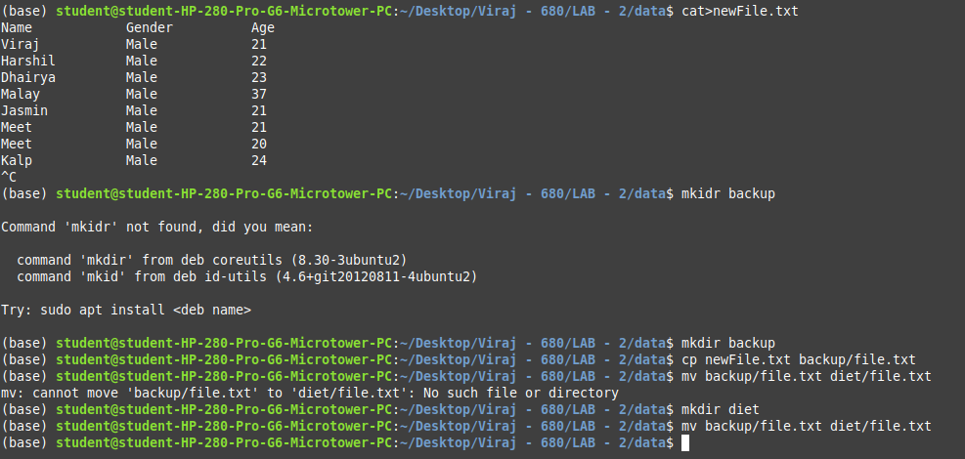

Part: B
1. Copy a file file.txt to a new location backup/file.txt, then move it to diet/file.txt

2. Extract the first and second fields from a file data.txt and merge them with another file extra.txt column-wise.
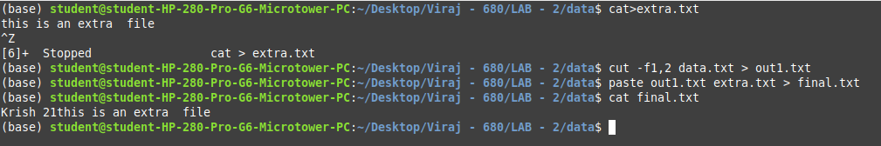

3. Create a directory called backup and copy all .txt files from the current directory into this backup folder.

4. Extract the first three fields from data1.txt, extract the first three fields from data2.txt, and combine them side by side.

Part: C

1. Display the system's kernel version and save the output to a file called sysinfo.txt, then copy the file to a folder named system_backup.

2. Create a directory project_backup, move all .sh files from the current directory to this new directory, then delete one of the .sh files from the backup.

3. Extract specific fields from file1.txt and file2.txt, combine them using paste, and display the result page by page using more.

Solution :-

Part A

1. Perform the following Unix Commands: who, whoami, uname, passwd, mkdir, rmdir, cp, mv, rm, cut, paste, more

Solution:
1. who – Shows users currently logged in
who
2. whoami – Shows your username
whoami
3. uname – Shows basic system information
uname
4. passwd – Changes your user password
passwd
5. mkdir – Creates a new directory
mkdir myfolder
6. rmdir – Removes an empty directory
rmdir myfolder
7. cp – Copies a file
cp file1.txt file2.txt
8. mv – Moves or renames a file
mv oldname.txt newname.txt
9. rm – Deletes a file
rm file.txt
10. cut – Extracts selected fields from a file
cut -f1 data.txt
11. paste – Merges files column-wise
paste file1.txt file2.txt
12. more – Shows a file page-by-page
more file.txt

Part B

1. Copy a file file.txt to backup/file.txt, then move it to diet/file.txt

Solution:
cp file.txt backup/file.txt
mv backup/file.txt diet/file.txt

2. Extract the first and second fields from data.txt and merge them with extra.txt column-wise

Solution:
cut -f1,2 data.txt > out1.txt
paste out1.txt extra.txt > final.txt

3. Create a directory backup and copy all .txt files from the current directory into this backup folder

Solution:
mkdir backup
cp *.txt backup/

4. Extract the first three fields from data1.txt and data2.txt, and combine them side-by-side

Solution:
cut -f1,2,3 data1.txt > d1.txt
cut -f1,2,3 data2.txt > d2.txt
paste d1.txt d2.txt > combined.txt

Part C

1. Display the system's kernel version and save the output to sysinfo.txt, then copy the file to a folder named system_backup

Solution:
uname -r > sysinfo.txt
mkdir system_backup
cp sysinfo.txt system_backup/

2. Create a directory project_backup, move all .sh files to this new directory, then delete one of the .sh files from the backup

Solution:
mkdir project_backup
mv *.sh project_backup/
rm project_backup/sample.sh # replace sample.sh with actual filename

3. Extract fields from file1.txt and file2.txt, combine them using paste, and display the result page-by-page with more

Solution:
cut -f1 file1.txt > f1.txt
cut -f1 file2.txt > f2.txt
paste f1.txt f2.txt | more

